* **Activity 5:**

### Creating Groups of Data

**Group by flight category and calculate the average ticket price for each category.**

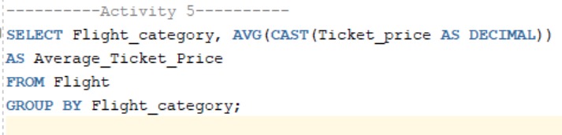

Output:

